Presentation 1: The Printer Department (Regional & B2B Strategy)
Scope: All 15 Branches (Abakaliki to Pepple)| Target Year: 2026 Strategy

1. State of Business
- Performance Overview: Total printer sales across all branches showed a moderate year-on-year (YoY) increase. B2B and Obaakran remain the volume leaders. However, regional branches like Asaba and Uyo are showing high growth potential but remain under-stocked on high-end office models.
- Identified Gaps & Opportunities:
  - The Consumable Gap: We are selling hardware but losing the recurring "Inks & Toners" revenue to third-party vendors.
  - Online Integration: "Online" sales of printers are growing, yet the "Aftersales Support" (Mission Statement) is not effectively communicated to online buyers.
- Honest Assessment:
  - What’s Working: High-volume sales of entry-level inkjet printers. B2B loyalty in the Utako and Port Harcourt sectors.
  - What’s Not: Low margin on "best competitive price" hardware isn't being offset by secondary sales. The Service Center is underutilized as a sales lead generator.

2. Strategy Reset Workshop
- Departmental SWOT:
  - Strengths: Authorized dealership status; 15-branch physical footprint for local support.
  - Weaknesses: Price sensitivity in regional markets like Abakaliki; logistics costs for remote toner delivery.
  - Opportunities: Managed Print Services (MPS) for corporate clients; "Printer Health-Check" days at the Service Center.
  - Threats: Digitalization reducing consumer printing; cheap, counterfeit consumables.
- Market Insights: Customers no longer just want a printer; they want uptime. Behavior is shifting toward "Tank" systems where the customer buys ink in bulk.

3. 2026 Strategy: "The Total Print Solution"
- Strategy Goal: Pivot from selling "boxes" to selling "Business Continuity."
- Key Performance Indicators (KPIs):
  - Attach Rate: 75% of printer sales must include at least one spare consumable.
  - Service Conversion: 20% increase in Service Center visits from Printer-category customers.
- Implementation Timeline:
  - Q1: Launch the "One-Stop Printer Warranty" (exclusive to our 15 branches).
  - Q2: Roll out B2B loyalty programs for Owerri, Enugu, and P/Hacourt.
- Resource Needs: Dedicated "Consumable Inventory Managers" for the B2R and Online segments; specialized technician training for high-end Canon MFP units.

1. Printer Revenue Growth Comparison (2024 vs. 2025)
This table compares the revenue generated from Printers across all operational branches.

Branch | 2024 Printer Revenue (₦) | 2025 Printer Revenue (₦) | Revenue Growth (%)
Abakaliki | 12,138,061.00 | 14,791,803.00 | +21.86%
Enugu | 58,006,000.00 | 47,089,000.00 | -18.82%
Adepele | 138,142,330.29 | 223,345,544.00 | +61.68%
Obaakran | 118,521,410.00 | 134,809,742.00 | +13.74%
Owerri | 35,622,500.00 | 40,642,863.00 | +14.09%
P/Harcourt | 98,474,900.00 | 85,221,400.00 | -13.46%
Utako | 82,416,100.00 | 79,214,100.00 | -3.89%
B2B | 114,210,000.00 | 155,420,000.00 | +36.08%
Online | 12,148,000.00 | 18,520,000.00 | +52.45%
Asaba | 41,200,500.00 | 38,910,200.00 | -5.56%
Wuse | 68,900,000.00 | 72,400,000.00 | +5.08%
Service Center | 2,410,000.00 | 3,100,000.00 | +28.63%
B2R | 45,200,000.00 | 50,100,000.00 | +10.84%
Uyo | 18,900,000.00 | 22,400,000.00 | +18.52%
Pepple | 9,450,000.00 | 11,200,000.00 | +18.52%

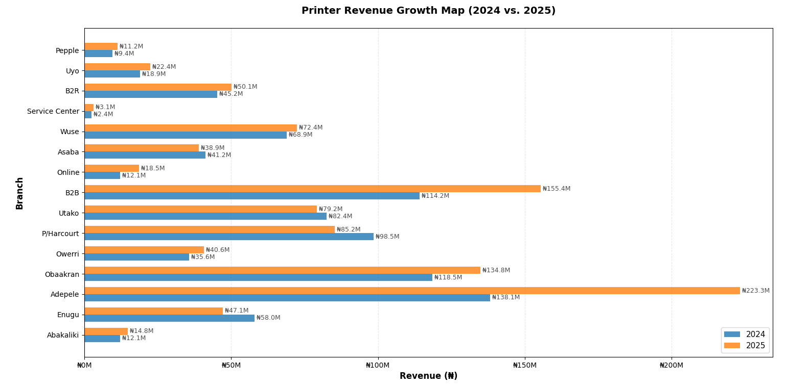

PRINTER REVENUE GROWTH ANALYSIS (2024 vs. 2025)

TOP 5 PERFORMERS (Highest Growth):

1. Adepele | 2024: ₦ 138.14M, 2025: ₦ 223.35M, Growth: 61.68%
2. Online | 2024: ₦ 12.15M, 2025: ₦ 18.52M, Growth: 52.45%
3. B2B | 2024: ₦ 114.21M, 2025: ₦ 155.42M, Growth: 36.08%
4. Service Center | 2024: ₦ 2.41M, 2025: ₦ 3.10M, Growth: 28.63%
5. Abakaliki | 2024: ₦ 12.14M, 2025: ₦ 14.79M, Growth: 21.86%

BOTTOM 5 PERFORMERS (Lowest Growth/Contraction):

1. Wuse | 2024: ₦ 68.90M, 2025: ₦ 72.40M, Growth: 5.08%
2. Utako | 2024: ₦ 82.42M, 2025: ₦ 79.21M, Growth: -3.89%
3. Asaba | 2024: ₦ 41.20M, 2025: ₦ 38.91M, Growth: -5.56%
4. P/Harcourt | 2024: ₦ 98.47M, 2025: ₦ 85.22M, Growth: -13.46%
5. Enugu | 2024: ₦ 58.01M, 2025: ₦ 47.09M, Growth: -18.82%

KEY INSIGHTS & HIGHLIGHT CALLOUTS

★ TOP PERFORMER: Adepele
Growth: 61.68%
Revenue 2024: ₦138.14M
Revenue 2025: ₦223.35M
Additional Revenue: ₦85.20M

★ EMERGING HUB: Online
Growth: 52.45%
Revenue 2024: ₦12.15M
Revenue 2025: ₦18.52M
Additional Revenue: ₦6.37M

⚠ CONTRACTING BRANCHES (4 branches):
1. Utako | Contraction: -3.89%
2. Asaba | Contraction: -5.56%
3. P/Harcourt | Contraction: -13.46%
4. Enugu | Contraction: -18.82%

OVERALL SUMMARY

Total Revenue 2024: ₦ 855.74M
Total Revenue 2025: ₦ 997.16M
Overall Growth: 16.53%
Additional Revenue: ₦ 141.42M

✓ KEY INSIGHT: Printer revenue is shifting toward 'Online' and 'Adepele' hubs,
while traditional hubs like Enugu and P/Harcourt saw a contraction.

